Lab 1 & Lab 2 Summary (26/01 - 27/01)
New Proposed Topology
- Replace L3 switches into routers
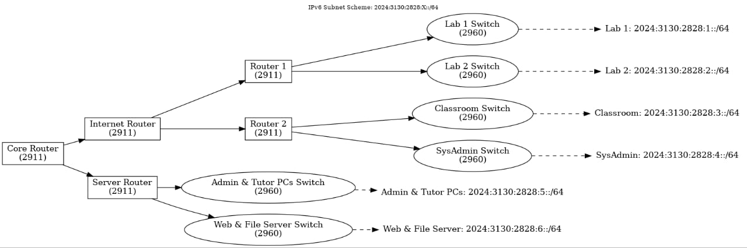
PT Implementation:
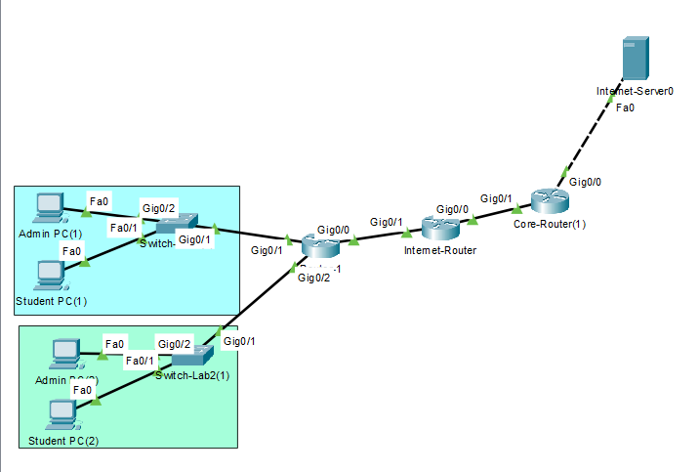
Hardware in PT:
Routers: 2911
Switch: 2960 IOS15
Server: Server-PT
Subnets:
 | Device | Interface | Connected To | IPv6 Address | Default Gateway
0 | Internet Server | Fa0 | Core Router | 2024:3130:2828::2/64 | 2024:3130:2828::1
1 | Core Router | G0/0 | Internet Server | 2024:3130:2828::1/64
2 |  | G0/1 | Internet Router | 2024:3130:2828:8::1/64
3 | Internet Router | G0/0 | Core Router | 2024:3130:2828:8::2/64
4 |  | G0/1 | Router1 | 2024:3130:2828:7::1/64
5 | Router1 | G0/0 | Internet Router | 2024:3130:2828:7::2/64
6 |  | G0/1 | Lab1 Switch | 2024:3130:2828:1::1/64
7 |  | G0/2 | Lab2 Switch | 2024:3130:2828:2::1/64
9 | Lab1 Switch | G0/1 | Router1
10 |  | G0/2 | Lab1 Admin PC
11 |  | Fa0/1 | Lab1 PC 1
12 | Lab1 PCs |  | Lab1 Switch | IPv6 Autoconfig (:1::) | -
13 | Lab2 Switch | G0/1 | Router 1 | 2024:3130:2828:2::2/64
14 |  | G0/2 | Lab2 Admin PC
 |  | Fa0/1 | Lab2 PC 1
 | Lab2 PCs |  | Lab2 Switch | IPv6 Autoconfig (:2::) | -

Static Routing:
At Device: | Outgoing | Incoming
Router1 | S ::/0 [1/0]  via 2024:3130:2828:7::1  Internet Router | .
Internet Router | S ::/0 [1/0]  via 2024:3130:2828:8::1  Core Router | S 2024:3130:2828:1::/64 [1/0]  via 2024:3130:2828:7::2  S 2024:3130:2828:2::/64 [1/0]  via 2024:3130:2828:7::2  Router 1 Subnet 1 & 2
Core Router |  | S 2024:3130:2828:1::/64 [1/0]  via 2024:3130:2828:8::2  S 2024:3130:2828:2::/64 [1/0]  via 2024:3130:2828:8::2  Internet Router Router 1 Subnet 1 & 2

Configurations:
Router1 | enable  conf t  hostname Router-1  ipv6 unicast-routing  ---  interface gig0/0  description “Link to Internet Router”  ipv6 address 2024:3130:2828:7::2/64  no shutdown  interface gig0/1  description “Link to Lab1-Switch”  ipv6 address 2024:3130:2828:1::1/64  no shutdown  interface gig0/2  description “Link to Lab2-Switch”  ipv6 address 2024:3130:2828:2::1/64  no shutdown  ---  ipv6 route ::/0 2024:3130:2828:7::1
Internet Router | enable  conf t  hostname Internet-Router  ipv6 unicast-routing  ---  interface gig0/0  description “Link to Core Router”  ipv6 address 2024:3130:2828:8::2/64  no shutdown  interface gig0/1  description “Link to Router1”  ipv6 address 2024:3130:2828:7::1/64  no shutdown  ---  ipv6 route ::/0 2024:3130:2828:8::1  ipv6 route 2024:3130:2828:1::/64 2024:3130:2828:7::2  ipv6 route 2024:3130:2828:2::/642024:3130:2828:7::2
Core Router | enable  conf t  hostname Core-Router  ipv6 unicast-routing  ---  interface gig0/0  description “Link to Internet Server”  ipv6 address 2024:3130:2828::1/64  no shutdown  interface gig0/1  description “Link to Internet Router”  ipv6 address 2024:3130:2828:8::1/64  no shutdown  ---  2024:3130:2828:1::/64 2024:3130:2828:8::2  2024:3130:2828:2::/64 2024:3130:2828:8::2

PC IP Configurations:
Automatic
Internet Server Services Configuration:
HTTP, HTTPS enabled
DNS enabled
- Add: www.example.com; 23.1.2.2

REFERENCE / NOTES

Below is a step-by-step guide for configuring the provided network topology in Cisco Packet Tracer.

Step 1: Core Router Configuration
Core Router is the central hub connecting the other routers.
- Access the Core Router CLI:
- enable
- configure terminal
- hostname CoreRouter
- ipv6 unicast-routing
- Configure the interfaces:
- interface gigabitEthernet 0/0
- description Link to Internet Router
- ipv6 address 2024:3130:2828:7::1/64
- no shutdown

- interface gigabitEthernet 0/1
- description Link to Server Router
- ipv6 address 2024:3130:2828:7::2/64
- no shutdown

Step 2: Internet Router Configuration
Internet Router connects to the internet and other internal routers.
- Access the CLI and configure:
- enable
- configure terminal
- hostname InternetRouter
- ipv6 unicast-routing
- Configure the interfaces:
- interface gigabitEthernet 0/0
- description Link to Core Router
- ipv6 address 2024:3130:2828:7::3/64
- no shutdown

- interface gigabitEthernet 0/1
- description Link to Router 1
- ipv6 address 2024:3130:2828:8::1/64
- no shutdown

- interface gigabitEthernet 0/2
- description Link to Router 2
- ipv6 address 2024:3130:2828:9::1/64
- no shutdown

Step 3: Router 1 Configuration
Router 1 connects to Lab 1 and Lab 2.
- Access the CLI:
- enable
- configure terminal
- hostname Router1
- ipv6 unicast-routing
- Configure the interfaces:
- interface gigabitEthernet 0/0
- description Link to Internet Router
- ipv6 address 2024:3130:2828:8::2/64
- no shutdown

- interface gigabitEthernet 0/1
- description Link to Lab 1
- ipv6 address 2024:3130:2828:1::1/64
- no shutdown

- interface gigabitEthernet 0/2
- description Link to Lab 2
- ipv6 address 2024:3130:2828:2::1/64
- no shutdown

Step 4: Router 2 Configuration
Router 2 connects to the Classroom and SysAdmin segments.
- Access the CLI:
- enable
- configure terminal
- hostname Router2
- ipv6 unicast-routing
- Configure the interfaces:
- interface gigabitEthernet 0/0
- description Link to Internet Router
- ipv6 address 2024:3130:2828:9::2/64
- no shutdown

- interface gigabitEthernet 0/1
- description Link to Classroom
- ipv6 address 2024:3130:2828:3::1/64
- no shutdown

- interface gigabitEthernet 0/2
- description Link to SysAdmin
- ipv6 address 2024:3130:2828:4::1/64
- no shutdown

Step 5: Server Router Configuration
Server Router connects to Administration and Tutor PCs, as well as the Web/File Servers.
- Access the CLI:
- enable
- configure terminal
- hostname ServerRouter
- ipv6 unicast-routing
- Configure the interfaces:
- interface gigabitEthernet 0/0
- description Link to Core Router
- ipv6 address 2024:3130:2828:7::4/64
- no shutdown

- interface gigabitEthernet 0/1
- description Link to Administration and Tutor PCs
- ipv6 address 2024:3130:2828:5::1/64
- no shutdown

- interface gigabitEthernet 0/2
- description Link to Web and File Servers
- ipv6 address 2024:3130:2828:6::1/64
- no shutdown

Step 6: Switch Configuration
Each switch is Layer 2, so minimal configuration is required.
- For Lab 1 Switch (2960):
- enable
- configure terminal
- vlan 1
- name Lab1
- interface vlan 1
- ipv6 address 2024:3130:2828:1::2/64
- no shutdown
Repeat similar steps for each switch, updating the VLAN name and IP address to match the corresponding subnet.

Step 7: End Device Configuration
Configure each end device (PCs/Servers) with an IPv6 address and default gateway:
- IPv6 Address: From the respective subnet (e.g., 2024:3130:2828:1::X/64).
- Default Gateway: The router interface IPv6 address (e.g., 2024:3130:2828:1::1).

Step 8: Testing Connectivity
- Use ping to test IPv6 connectivity between devices.
- Use traceroute for route verification:
- traceroute ipv6 2024:3130:2828:6::2

This step-by-step setup ensures a properly functioning network in Cisco Packet Tracer. Let me know if you need further assistance!

I have created the addressing table for your network and displayed it. Let me know if you need any modifications or further details.
 | Device | Interface | Connected To | IPv6 Address
1 | Core Router | G0/0 | Internet Router | 2024:3130:2828:7::1/64
2 | Internet Router | G0/1 | Server Router | 2024:3130:2828:7::2/64
3 | Router 1 | G0/0 | Core Router | 2024:3130:2828:8::1/64
4 | Router 1 | G0/1 | Lab 1 Switch | 2024:3130:2828:1::1/64
5 | Router 2 | G0/2 | Lab 2 Switch | 2024:3130:2828:2::1/64
6 | Router 2 | G0/0 | Internet Router | 2024:3130:2828:9::1/64
7 | Server Router | G0/1 | Classroom Switch | 2024:3130:2828:3::1/64
8 | Server Router | G0/2 | SysAdmin Switch | 2024:3130:2828:4::1/64
9 | Lab 1 Switch | G0/1 | Router 1 | 2024:3130:2828:1::2/64
10 | Lab 2 Switch | G0/2 | Router 1 | 2024:3130:2828:2::2/64
11 | Classroom Switch | G0/1 | Router 2 | 2024:3130:2828:3::2/64
12 | SysAdmin Switch | G0/2 | Router 2 | 2024:3130:2828:4::2/64
13 | Admin & Tutor Switch | G0/1 | Server Router | 2024:3130:2828:5::2/64
14 | Web & File Server Switch | G0/2 | Server Router | 2024:3130:2828:6::2/64

Static Routing:
At Router 1:
S ::/0 [1/0]
via 2024:3130:2828:7::1
S 2024:2120:2828::/64 [1/0]
via 2024:3130:2828:1::1
via 2024:3130:2828:2::1

At Internet Router:
ipv6 route 2024:3130:2828:1::/64 2024:3130:2828:7::2
- Handles routing towards to subnet 1
ipv6 route 2024:3130:2828:2::/64 2024:3130:2828:7::2
- Handles routing towards to subnet 2

S ::/0 [1/0]
via 2024:3130:2828:8::1
S 2024:3130:2828:1::/64 [1/0]
via 2024:3130:2828:7::2
S 2024:3130:2828:2::/64 [1/0]
via 2024:3130:2828:7::2

At Router Core:
S 2024:3130:2828:1::/64 [1/0]
via 2024:3130:2828:8::2
S 2024:3130:2828:2::/64 [1/0]
via 2024:3130:2828:8::2

